G.SAI CHARAN
BATCH-01
2403A51023

TASK1:
Subgroup H
H.1 — [S13H1] Extract hashtags and mentions
Scenario (agritech):
Context:
Moderation in the agritech app needs hashtag and mention extraction.
Your Task:
Use regex to extract @mentions and #hashtags (case-insensitive) and return lowercase lists.
Data & Edge Cases:
Punctuation around tags should be ignored.
AI Assistance Expectation:
Ask AI for a robust regex and tests covering multiple tags.
Constraints & Notes:
Return mentions and hashtags lists; lowercase.
Sample Input:
Hello @alice check #AI and #Python with @Bob
Sample Output:
mentions=['alice','bob'], hashtags=['ai','python']
Acceptance Criteria: Lowercased; ignores punctuation

PROMPT:
Extract all @mentions and #hashtags from the input text Strip punctuation convert to lowercase and return two separate lists one for mentions one for hashtags
text = "Hello @alice check #AI and #Python with @Bob"

CODE:

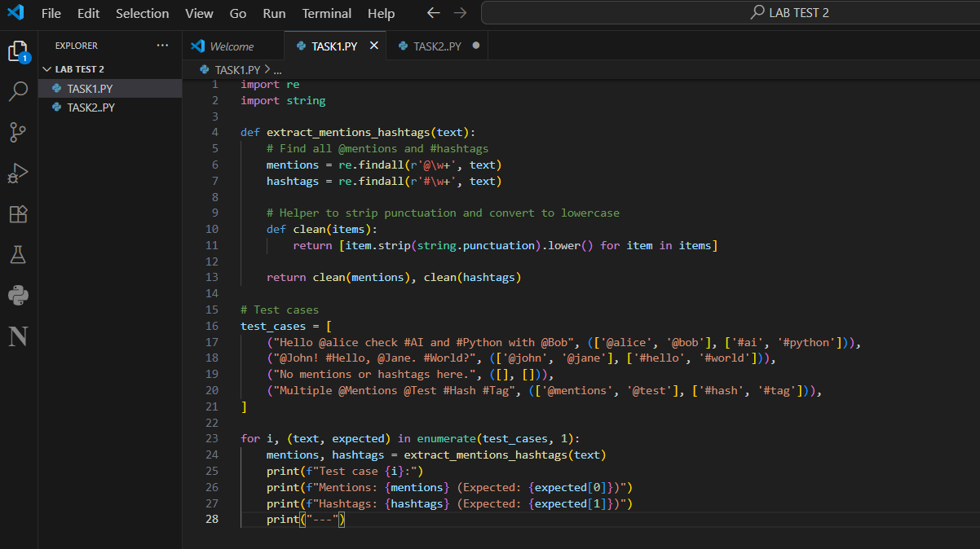

OUTPUT:
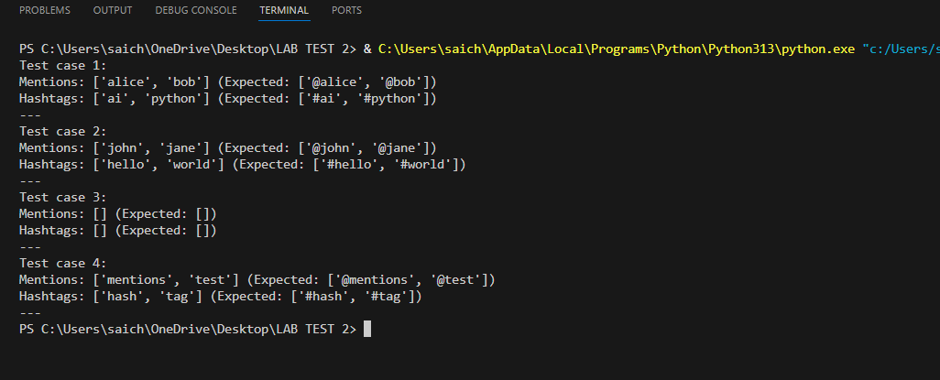

H.2 — [S13H2] Shortest path on weighted graph (Dijkstra)
Scenario (agritech):
Context:
Routing decisions in the agritech graph need shortest paths for small, weighted graphs.
Your Task:
Implement Dijkstra from a source node 'A' to all nodes using a priority queue.
Data & Edge Cases:
Use adjacency dict with positive weights.
AI Assistance Expectation:
Prompt AI to outline the algorithm steps and edge relaxation pattern.
Constraints & Notes:
Return dict of distances with 0 for source.
Sample Input
{'A':{'B':1,'C':4},'B':{'C':2,'D':5},'C':{'D':1},'D':{}}
Sample Output
{'A':0,'B':1,'C':3,'D':4}
Acceptance Criteria: Correct distances; stable for positive weights

PROMPT:
Implement Dijkstra's algorithm using a priority queue to find the shortest paths from source node 'A' in a weighted graph with positive edge weights

CODE:
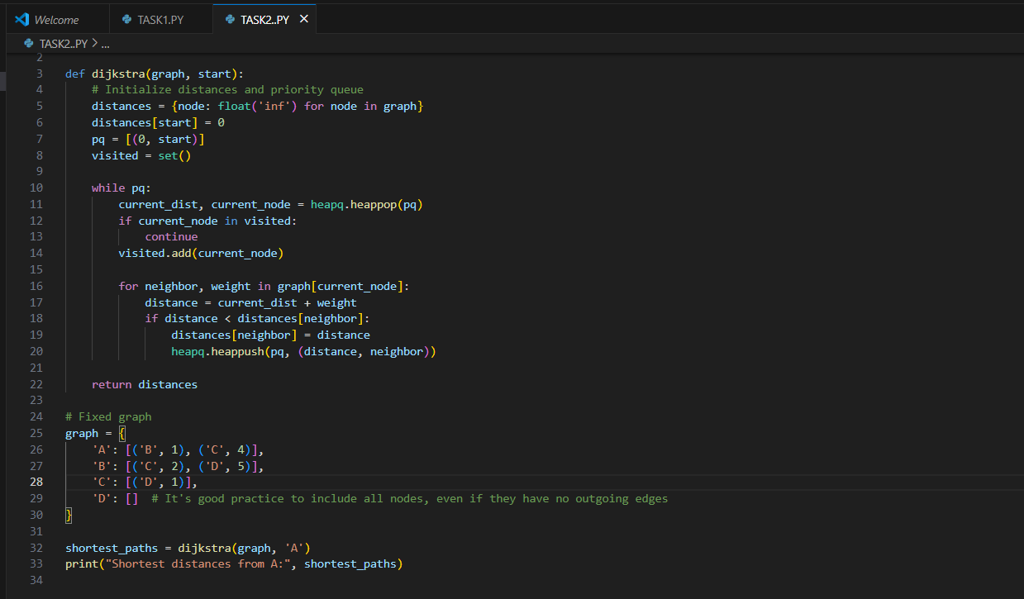

OUTPUT:

